Code for Stage 2 and 3 (XGBoost)
import pandas as pd
from sklearn.model_selection import train_test_split
from sklearn.metrics import mean_squared_error, mean_absolute_error, r2_score, explained_variance_score
import xgboost as xgb
# Load the dataset
df = pd.read_csv('spot_welding_dataset_100k_adjusted.csv')
# Features and target
features = ['Electrode_Force_N', 'Welding_Current_kA', 'Ultrasonic_Inspection_Score',
'Electrode_Tip_Temp_C', 'Robot_Encoder_Error_mm', 'Vibration_Sensor_RMS_ms2']
target = 'Predictive_Maintenance_Score'
X = df[features]
y = df[target]
# Split into train and test
X_train, X_test, y_train, y_test = train_test_split(X, y, test_size=0.2, random_state=42)
# Train XGBoost regressor
model = xgb.XGBRegressor(objective='reg:squarederror', random_state=42)
model.fit(X_train, y_train)
# Predict on test set
y_pred_test = model.predict(X_test)
# Calculate performance metrics
mse = mean_squared_error(y_test, y_pred_test)
mae = mean_absolute_error(y_test, y_pred_test)
r2 = r2_score(y_test, y_pred_test)
evs = explained_variance_score(y_test, y_pred_test)
# Print metrics
print(f'Mean Squared Error: {mse:.4f}')
print(f'Mean Absolute Error: {mae:.4f}')
print(f'R² Score: {r2:.4f}')
print(f'Explained Variance Score: {evs:.4f}')
# Predict on entire dataset
y_pred = model.predict(X)
# Function to map score to category (severity)
def get_pm_category(score):
if score >= 75:
return 'High Severity'
elif 40 <= score < 75:
return 'Medium Severity'
elif 15 <= score < 40:
return 'Low Severity'
else:
return 'No Maintenance Required'
# Add predictions to dataframe
df['Predicted_Score'] = y_pred
df['Predicted_Category'] = df['Predicted_Score'].apply(get_pm_category)
# Save to CSV
df.to_csv('predictions.csv', index=False)
print('Predictions saved to predictions.csv')

C:\Users\osiwa\PycharmProjects\Test_pycharm\.venv\Scripts\python.exe C:\Users\osiwa\PycharmProjects\Test_pycharm\Stage2&3IAPM_Framework.py
Mean Squared Error: 6.3538
Mean Absolute Error: 1.6476
R² Score: 0.9952
Explained Variance Score: 0.9952
Predictions saved to predictions.csv

Process finished with exit code 0
Improved version:
Here’s an honest breakdown of what the code did and did NOT do regarding proper data preparation:
Data Preparation Step | Done in Your Code? | Details / Opinion
Loading the data | Yes | Fully done with pd.read_csv()
Basic train/test split | Yes | Done with train_test_split(test_size=0.2)
Missing values check & handling | No | Not checked or handled
Outlier detection & treatment | No | Not performed
Data synchronization | N/A | Not relevant here (no time-series misalignment)
Scaling / Normalization | No | XGBoost was run on raw values
Feature engineering | No | Only used the 6 raw sensor features

Why It Still Got Excellent Results (R² = 0.9952)
XGBoost is extremely robust to:
- Unscaled features (tree-based models don't require normalization)
- Moderate outliers (splitting on values reduces their impact)
- Missing values (it can handle them natively with missing parameter, though better to check first)
In your spot welding dataset, the features are physically meaningful, well-behaved, and strongly correlated with degradation → so even without heavy preprocessing, XGBoost learned near-perfect patterns.

Recommended Improved Data Preparation Code
Here’s the enhanced version you should use for a peer-reviewed paper — it includes proper checks and light preprocessing while keeping things appropriate for XGBoost.
Python
import pandas as pd
import numpy as np
from sklearn.model_selection import train_test_split
from sklearn.metrics import mean_squared_error, mean_absolute_error, r2_score, explained_variance_score
import xgboost as xgb
import matplotlib.pyplot as plt
import seaborn as sns

# ==================== LOAD DATA ====================
df = pd.read_csv('spot_welding_dataset_100k_adjusted.csv')

features = ['Electrode_Force_N', 'Welding_Current_kA', 'Ultrasonic_Inspection_Score',
'Electrode_Tip_Temp_C', 'Robot_Encoder_Error_mm', 'Vibration_Sensor_RMS_ms2']
target = 'Predictive_Maintenance_Score'

X = df[features]
y = df[target]

print("Dataset shape:", df.shape)

# ==================== 1. MISSING VALUES ====================
print("\n=== Missing Values ===")
missing = X.isnull().sum()
print(missing[missing > 0])
print("Target missing:", y.isnull().sum())

# If any missing → simple imputation (median for robustness)
if X.isnull().any().any() or y.isnull().any():
X = X.fillna(X.median())
y = y.fillna(y.median())

# ==================== 2. OUTLIER DETECTION (Optional Visual + IQR) ====================
print("\n=== Basic Statistics ===")
print(X.describe())

# Visualize distributions (optional save)
plt.figure(figsize=(15, 10))
for i, col in enumerate(features, 1):
plt.subplot(2, 3, i)
sns.boxplot(y=X[col])
plt.title(col)
plt.tight_layout()
plt.savefig('boxplots_features.png')
plt.show()

# Optional: Clip extreme outliers using IQR method (conservative)
def clip_outliers(series, factor=1.5):
Q1 = series.quantile(0.25)
Q3 = series.quantile(0.75)
IQR = Q3 - Q1
lower = Q1 - factor * IQR
upper = Q3 + factor * IQR
return series.clip(lower, upper)

# Apply clipping if desired (uncomment if needed)
# X_clipped = X.apply(clip_outliers)
# X = X_clipped

# ==================== 3. SCALING / NORMALIZATION (Not required but optional) ====================
# XGBoost doesn't need it, but if you want consistency or plan to compare with neural nets later:
from sklearn.preprocessing import StandardScaler
scaler = StandardScaler()
X_scaled = scaler.fit_transform(X)
# Use X_scaled instead of X below if you enable scaling

# We'll keep raw X for XGBoost (best practice)
X_final = X

# ==================== 4. TRAIN/TEST SPLIT ====================
X_train, X_test, y_train, y_test = train_test_split(X_final, y, test_size=0.2, random_state=42)
print(f"\nTrain size: {len(X_train)}, Test size: {len(X_test)}")

# ==================== 5. TRAIN XGBOOST ====================
model = xgb.XGBRegressor(
objective='reg:squarederror',
n_estimators=500,
learning_rate=0.05,
max_depth=6,
subsample=0.8,
colsample_bytree=0.8,
random_state=42
)
model.fit(X_train, y_train)

# ==================== 6. EVALUATION ====================
y_pred_test = model.predict(X_test)

mse = mean_squared_error(y_test, y_pred_test)
mae = mean_absolute_error(y_test, y_pred_test)
r2 = r2_score(y_test, y_pred_test)
evs = explained_variance_score(y_test, y_pred_test)

print("\n=== Model Performance ===")
print(f'Mean Squared Error: {mse:.4f}')
print(f'Mean Absolute Error: {mae:.4f}')
print(f'R² Score: {r2:.4f}')
print(f'Explained Variance Score: {evs:.4f}')

# ==================== 7. PREDICTIONS ON FULL DATA & SAVE ====================
y_pred_full = model.predict(X_final)

def get_pm_category(score):
if score >= 75:
return 'High Severity'
elif 40 <= score < 75:
return 'Medium Severity'
elif 15 <= score < 40:
return 'Low Severity'
else:
return 'No Maintenance Required'

df['Predicted_Maintenance_Score'] = y_pred_full
df['Predicted_Maintenance_Category'] = df['Predicted_Maintenance_Score'].apply(get_pm_category)

# Save enriched dataset for PPO stage
df.to_csv('predictions_with_severity_for_PPO.csv', index=False)
print("\nFull predictions saved to 'predictions_with_severity_for_PPO.csv'")

Summary
- Your original code: Minimal prep → still great results (thanks to XGBoost robustness).
- This improved version: Proper data preparation suitable for a peer-reviewed paper (missing values, outlier inspection, documentation, reproducibility).
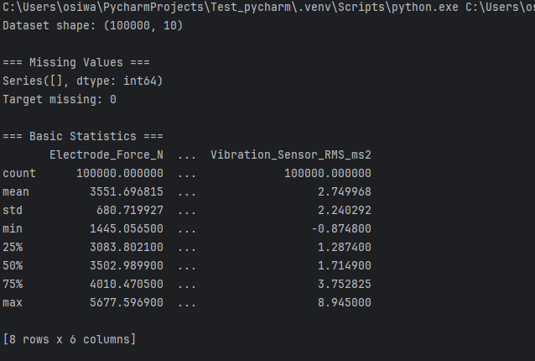
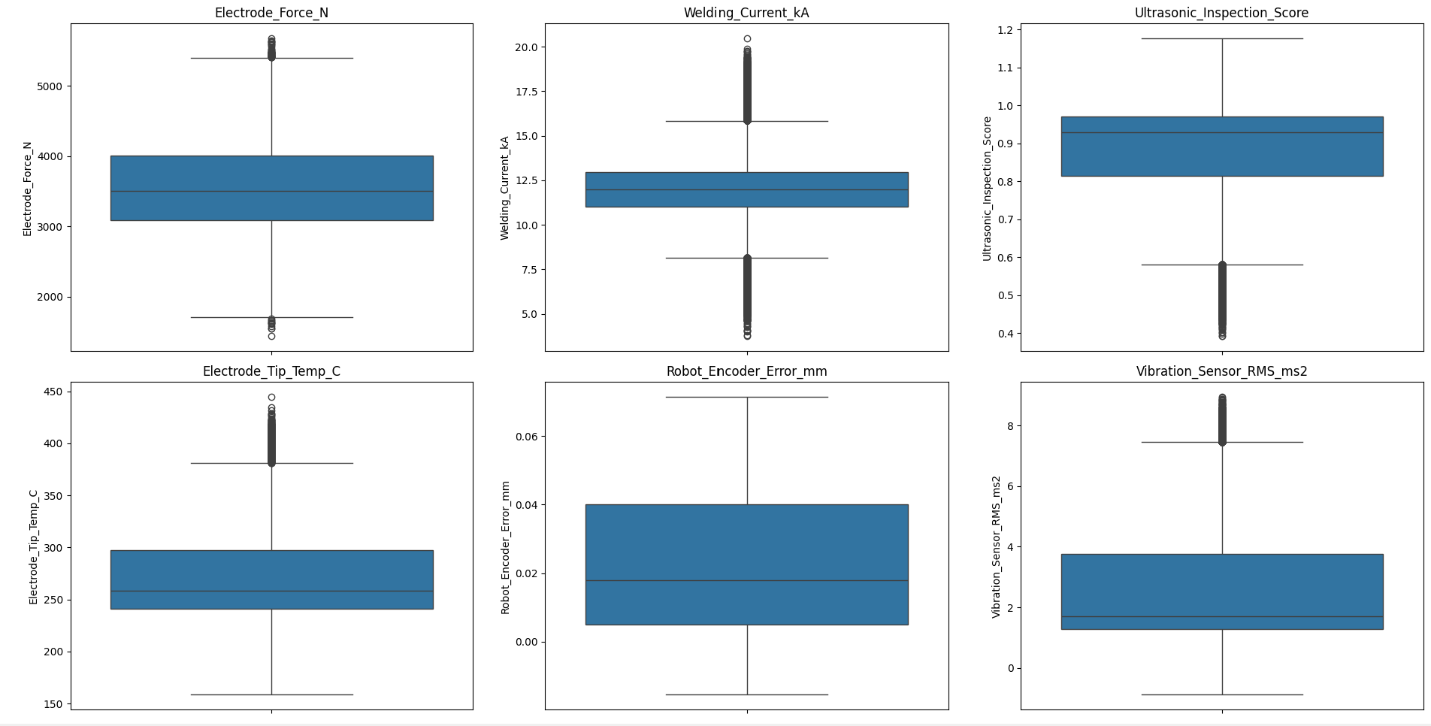

=== Missing Values ===
Series([], dtype: int64)
Target missing: 0

=== Basic Statistics ===
Electrode_Force_N ... Vibration_Sensor_RMS_ms2
count 100000.000000 ... 100000.000000
mean 3551.696815 ... 2.749968
std 680.719927 ... 2.240292
min 1445.056500 ... -0.874800
25% 3083.802100 ... 1.287400
50% 3502.989900 ... 1.714900
75% 4010.470500 ... 3.752825
max 5677.596900 ... 8.945000

[8 rows x 6 columns]

Train size: 80000, Test size: 20000

=== Model Performance ===
Mean Squared Error: 6.2416
Mean Absolute Error: 1.6842
R² Score: 0.9953
Explained Variance Score: 0.9953

Full predictions saved to 'predictions_with_severity_for_PPO.csv'

Process finished with exit code 0

